**LP5 (Test on Edge Browser)**

**1.Verify the Header-**

(a) Logo should redirect to the correct link.

Logo is not redirected to the correct link or page.

(b) Logo link should open in a new tab.

No, it’s is not working.

**2.Verify the Footer-**

(a) Verify redirection of Links and content.

Link and Content is not redirected to the new page or link.

(b) Verify social icons' redirection.

There is a social icon but it is not working and it is redirected to the same websites.

**3.Verify Correct Favicon- Favicon should be the same as it is on the client's live website.**

No Favicon is there.

**4.Verify the Font-family- Verify font family is consistent throughout(unless special   requirement by client).**

There is a spelling mistakes in the font which is highlight in the given snapshot below.

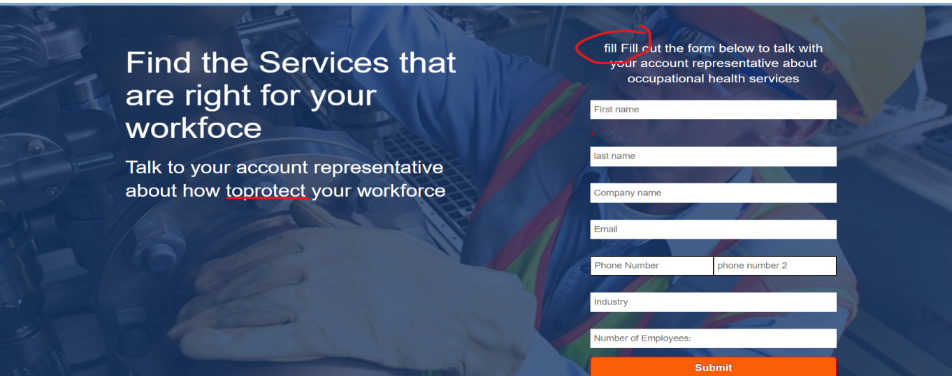

In this there is a spelling mistake.

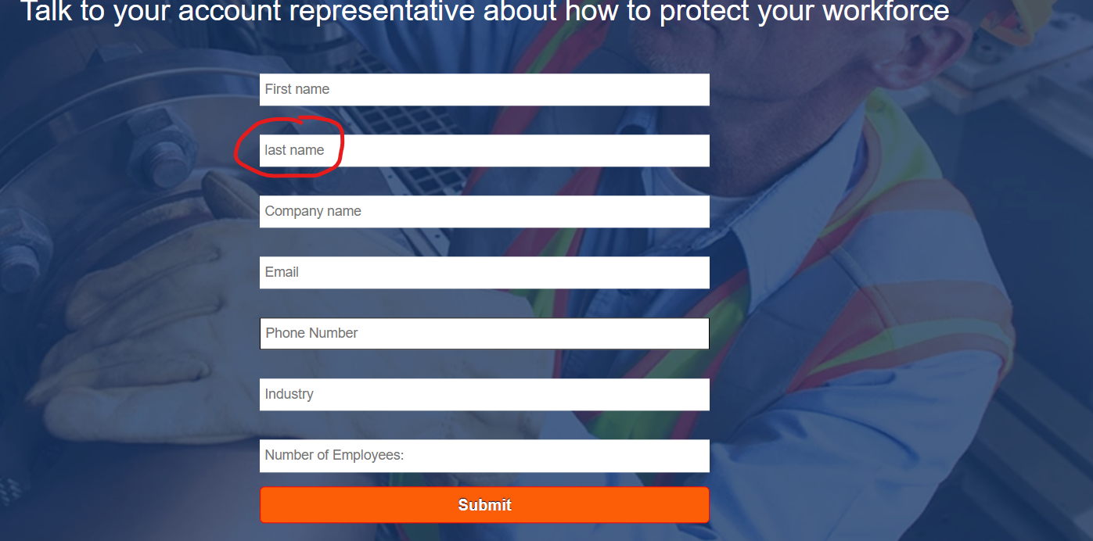

**5.Verify the redirection of links-**

(a) All CTAs, links and icons should redirect to correct pages.

All CTA, Links and Icon is not redirected to same pages.

(b) Add note to developer if # is used for links.

Remove all ‘#’ from the last of links for all CTA, Links and Social Icons.

**6.Verify the Spacing - Verify Spacing and alignment of the page should not break.**

In the given web page, the spacing of the website is totally un aligned. Which shows the bad impact on user.

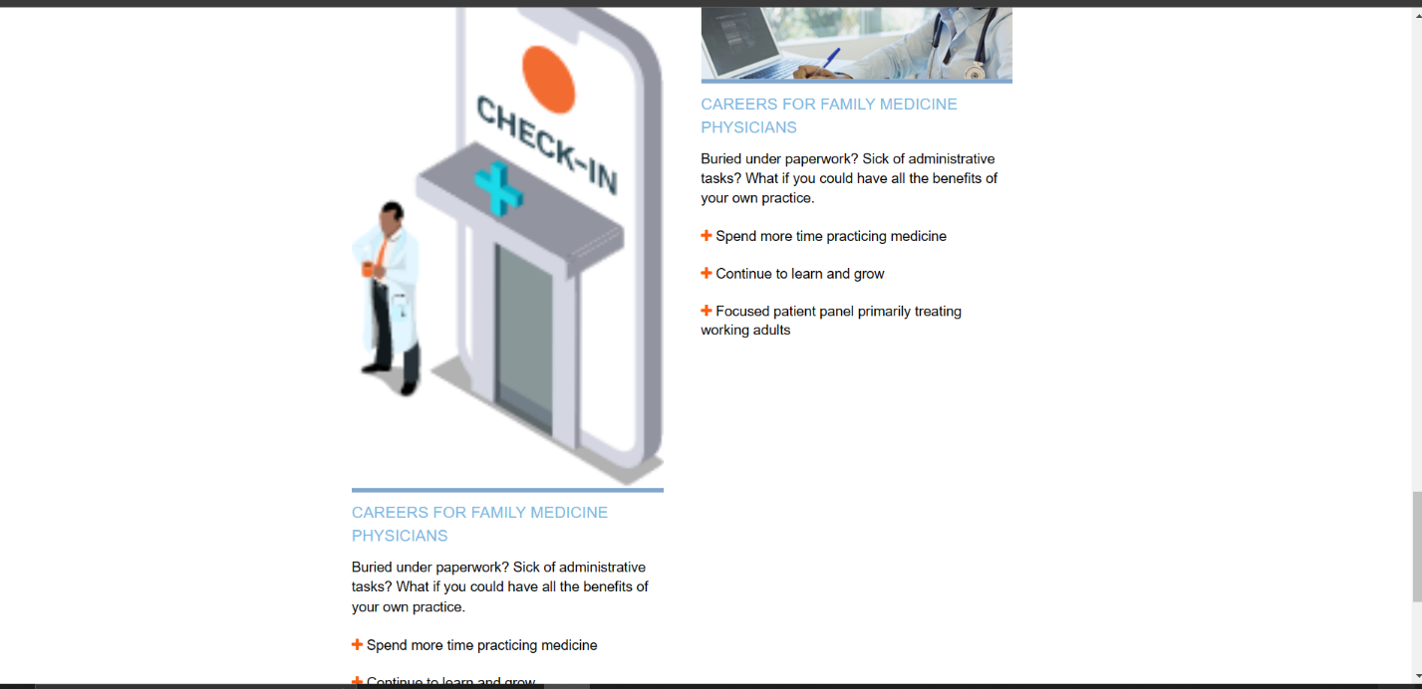

**7.Verify Form-**

(a) Verify alignment and spacing of form.

Alignment between the first name and the last name is not correct, otherwise overall good.

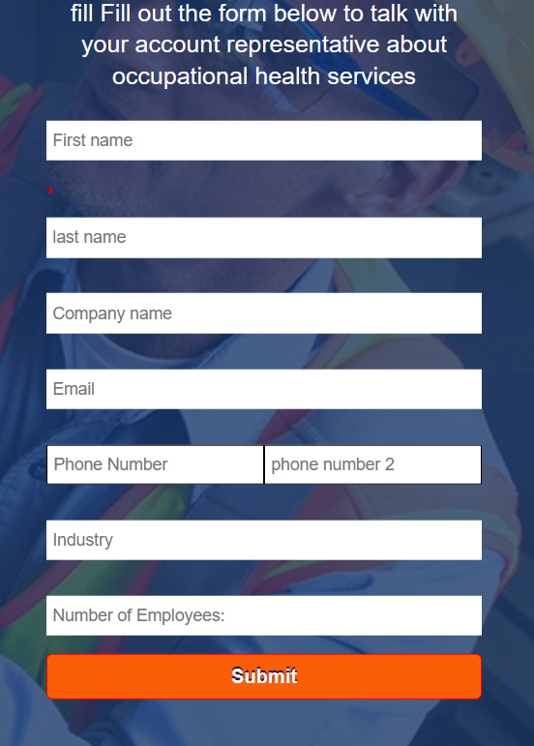

(b) Verify * is used for Mandatory Fields.

In this the last name box is mandatory for filling the form.

(c) Verify it is showing correct error messages.

There is no error message is shown when we filling the form.

**8.Verify Thank you message after submitting form- If Required.**

Submit button is not working, So ‘Thankyou’ message is not coming on the screen.

**9.Verify Landing page on cross browsers- Google Chrome, Firefox, Internet Explorer and MAC (Safari).**

Yes, it is working on Google, Chrome, Edge and Firefox.

**10.Verify Responsive- Verify it on iPhone and iPad on simulator or live device.**